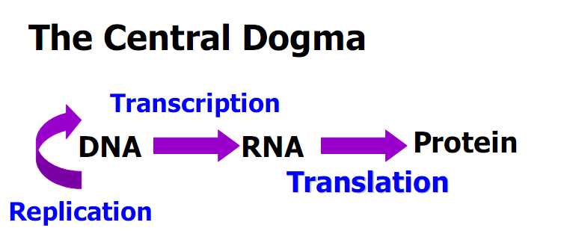

中心法则

**“The genetic code is degenerate”What does it mean? What’s the benefits?**

it means that many amino acids are speafied by more than one codon

Code degeneracy explains how therecan be great variation in the AT/GC ratios in the DNA of various organisms without large changes in the proportion of amino acids in their proteins.

The benefit:

1.The genetic code evolved in such a way as to minimize the deleterious effects of mutations.

2.Code degeneracy may serve as asafety mechanism to minimize errors in the reading of codons.

**What’s about the anticodonrecognition? How the code was discovered?**

**What are the three rules governing the genetic code? What are the mutations altering genetic code?**

Some tRNA could recognize several different codons

Inosine【次黄(嘌呤核)苷】 is present in the anticodonloop as a fifth base

**Wobble Concept**

the 5’end of the anticodonis not as spatially confined as the other two, allowing it to form hydrogen bonds with more than onebases located at the 3’end of a

codon.

**Why wobble is allowed at the 5’anticodon**

• The 3-D structure of tRNA shows that the stacking interactions between the

flat surfaces of the 3 anticodonbases + 2 followed bases position the first (5’)

anticodonbase at the end of the stack, thus less restricted in its movements.

• The 3’base appears in the middle of the stack, resulting in the restriction of its

movements.

Three codons, UAA, UAG, and UGA signify chain termination.

**THREE RULES GOVERN THE GENETIC CODE**

1 Codonsare read in a 5’to 3’ direction.

2 Codonsare nonoverlapping and the message contains no gaps.

3 The message is translated in a fixed reading frame which is set by the initiation codon.

**Three Kinds of Point Mutations Alter the Genetic Code**

1. Missense（错义） mutation: An alternation that changes a codonspecific for one amino acid to a codonspecific for another amino acid.

2. Nonsense无（意）义or stop mutation: An alternation causing a change to a chain-termination codon.

3. Frameshift(移码) mutation:Insertions or deletions of one or a small number of base pairs that alter the reading frame.

**Reverse the harmful mutations by a second genetic change**

①Reverse (back) mutations: change an altered nucleotide sequence back to its

original arrangement.

②Suppressor mutations: suppress the change due to mutation at site A by

producing an additional genetic change at site B.

(1) Intragenic基因内的suppression

(2) Intergenic基因间的suppression

**Benefits of the universal codes**

(1)Allow us to directly compare the protein coding sequences among all

organisms.

(2) Make it possible to express cloned copies of genes encoding useful protein in different host organism. Example: Human insulin expression in bacteria

**What are the benefits of the code universality? What’s about the**

**mitochondrial codes and tRNAs?**

the genetic code is slightly different from the standard code.

Mitochondrial tRNAs are unusual in the way that they decode mitochondrial messages.

Only 22 tRNAs are present in mammalian mitochondria. The U in the 5’ wobble position of a tRNA is capable of recognizing all four bases in the 3’ of the codon.